Jack Stinton Dance Company

Education Pack for Academic Year 2015/2016

Here at Jack Stinton Dance Company, we have a passion for creating passion.

Jack and the current members of the company were all introduced to contemporary dance via workshops delivered in either primary or secondary school. It was participation in these workshops, which sparked the dancers desire to pursue dance and the arts professionally.

As an educational company JSDC aim to deliver workshops which inspire, educate and motivate pupils during their school career. Not only that, we believe students should have the opportunity to explore their own creativity and express themselves in a fun, energetic and rewarding environment.

“My personal aim with our education work is to offer the same chance that was offered to me; an opportunity to explore movement and spark something deep within our students” – Jack Stinton, Artistic Director

We currently offer a variety of successful workshops and classes, tailored specifically to the school, age, gender and ability of our pupils. We also offer regular after school classes, ranging in length, ability and style. Projects can also be undertaken with our new
Arts Award scheme.

The following pack is a summary of all the workshops currently offered.

Classes and Workshops for Primary Schools
These highly positive workshops are currently being delivered in a number of schools in the local area, such as Over, St Ives and Caister. For primary school ages, we aim to co-ordinate with topics being focused on in school in order to maintain a sense of familiarity for pupils. For example recent topics covered in these workshops have included World War 2, Ancient Egypt and Famous People. These workshops can be scheduled within the students PE sessions, a teachers PPA time or can be taken for an entire day, depending on the level of intensity required.

Within PE Sessions
JSDC aim to base these sessions around content that the students are currently being taught in class. Workshops will explore these topics in a creative and fun manner. Classes will feature a short warm-up followed by either the chance to learn and improve on a short section of choreography taught by the JSDC tutor, or the chance for the students to create and develop their own movement based around tasks set by the tutor. These tasks are usually done in small groups, with a chance for the students to perform, watch and share feedback at the end of the class.
Over the period of time that JSDC are in the school, we aim to develop short performances for each class we work with and at the end of the project, the work the children have created can be performed to other classes or year groups in assembly. This is an important part of the process; giving the children a real confidence boost, developing performance skills and offering them a real sense of achievement.
In addition, we also offer support to help develop confidence in primary school teachers when delivering contemporary dance. We do this by providing full lesson plans, covering the knowledge required to teach a basic contemporary dance technique and creative session. If JSDC are in school for long enough (usually at least 1 full half term) JSDC will give the class teacher a chance to lead the warm up and some of the creative work. We will then offer feedback to the teacher for their CPD. Full lesson plans, technical breakdowns and feedback are provided at the end of the project.
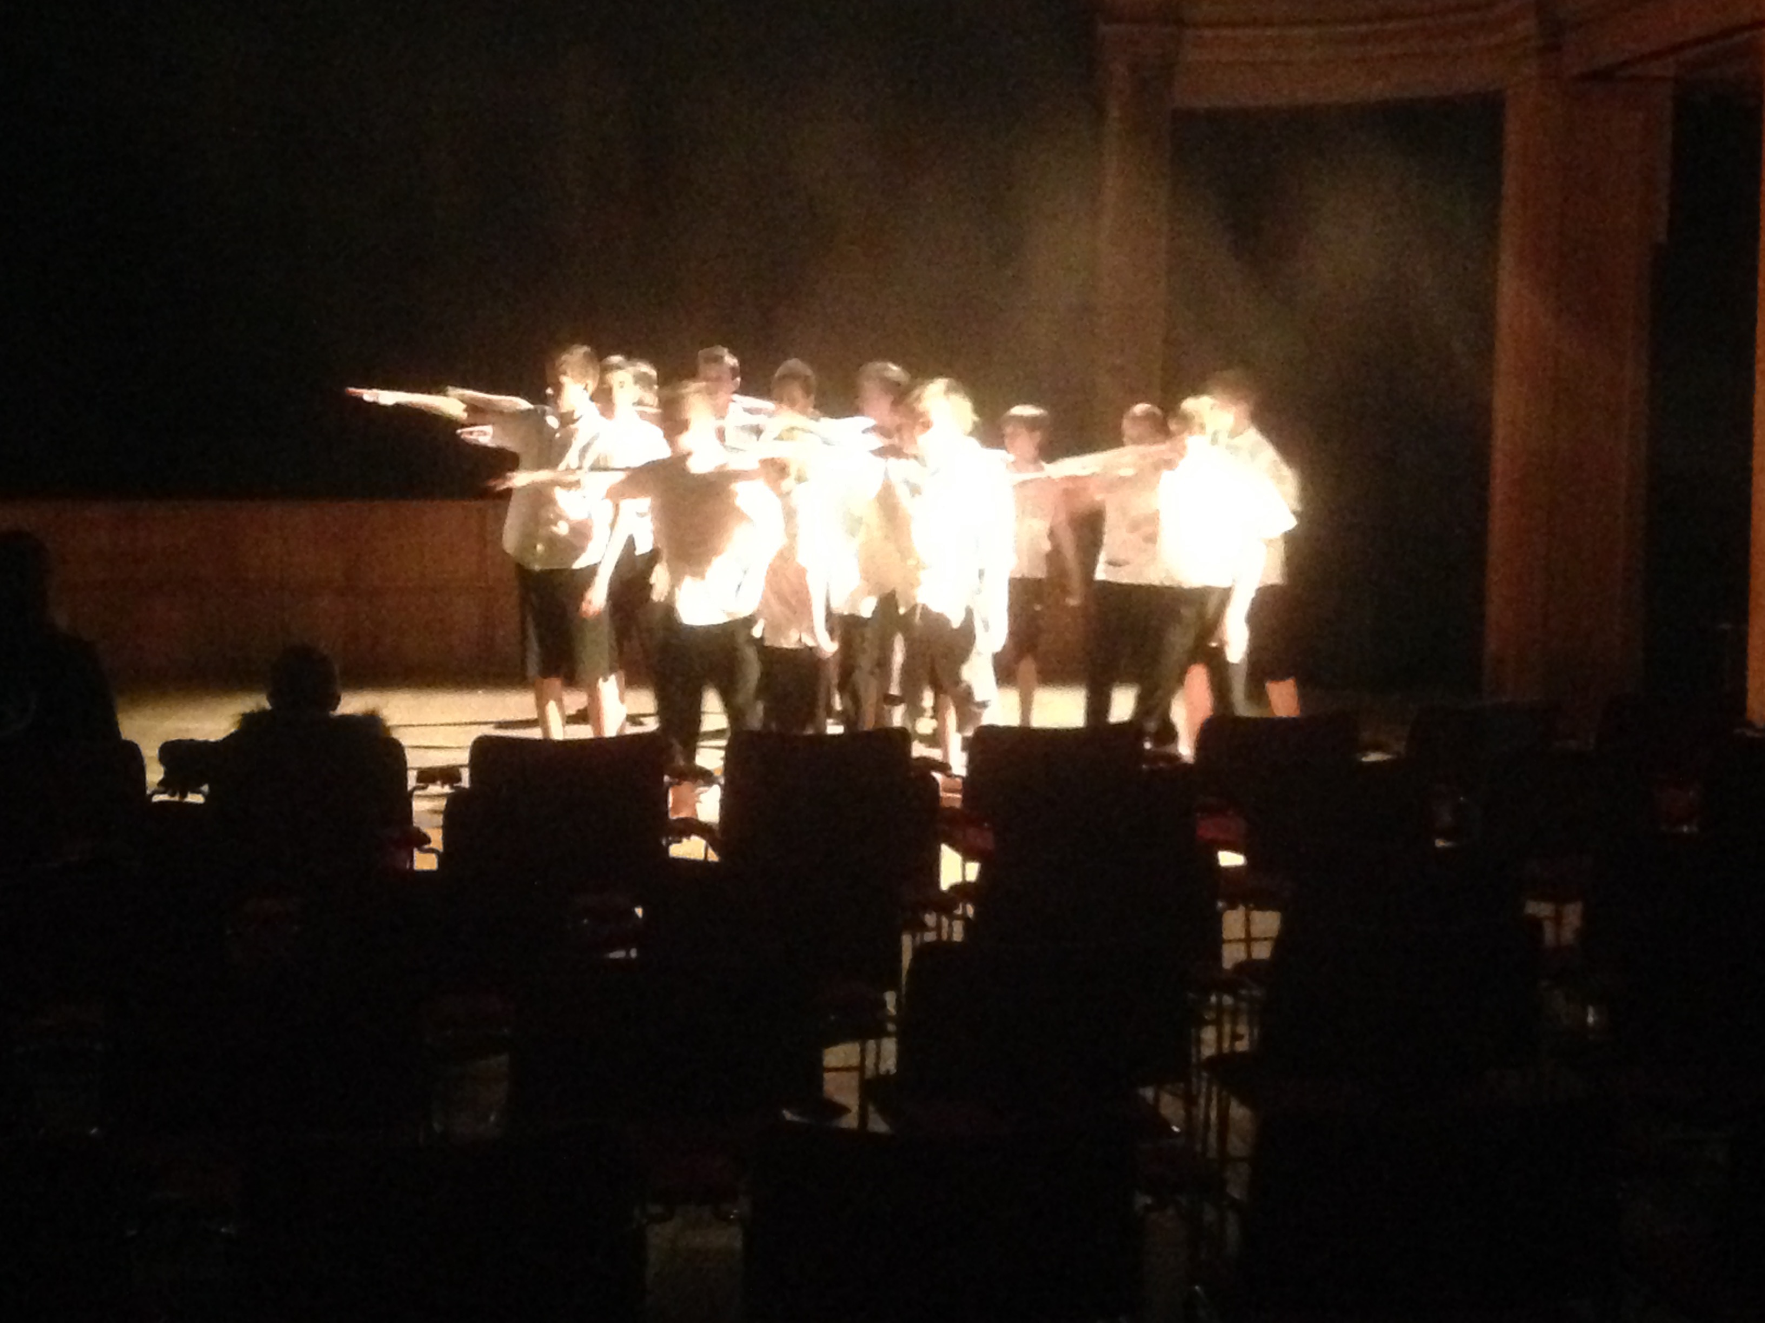
All Day Workshops
Every workshop begins with a warm-up using fun and creative games exploring movement and learning names of each other and important technical names. We proceed with a short contemporary technique class, demonstrating and improving the basics of posture, strength and flexibility. These exercises are brief and concise and are usually repeated a number of times to develop full understanding. The group will then learn a short movement phrase created by the JSDC tutor, complimenting the theme of the workshop.

The creative section of the day follows, giving the pupils the opportunity to explore and suggest ideas. Students are then required to develop ideas through movement and exploration. This is practiced along with the routine taught by the JSDC tutor in small groups and finally performed in front of their peers at the end of the day. Feedback from these workshops has been highly rewarding, with students enjoying the opportunity to explore the topic through movement whilst working creatively in a fun, group setting.

“What an amazing day!! Jack Stinton Dance Company visited our school and a range of pupils were selected to participate in workshops, including some of our Pupil Premium children… They were treated to a vibrant, thought provoking workshop and performance by the company members… The work was inspirational and also aspirational for pupils in a coastal area who rarely experience such work.”
Coral Brinklow: Head of Caister Junior School 04/07/2014

After School Dance Programme
JSDC also offer regular after school classes, lasting 30 minutes to 1 hour, depending on age and style directly after school. This class consists of a warm-up followed by a simple technique class. We then create a short routine/performance, which includes a combination of the students own creative work and the JSDC tutor’s phrase. This routine is developed over the term in the hope of a performance at the school when appropriate. The company also has several local and national performances each year and our regular classes/students are often given the opportunity to perform at these shows. Recent projects have been performed at Energise Youth Dance Festival and Move|Be Moved. The tutors at JSDC have studied and are capable of teaching a wide variety of dance styles. Please call or email to discuss what styles you are interested in bringing to your school. Popular styles include Street Dance, Ballet and Contemporary.

Classes and Workshops for Secondary Schools
We have delivered many workshops to secondary schools including Netherhall, Swavesey and Clare (Suffolk). These were fantastically received and have been favourably compared to workshops delivered by large, internationally known companies. We offer the opportunity to work within students Dance/PE classes or full day workshops. We also create BTEC and GCSE exam performance pieces.

Our classes and workshops both follow a similar setup. The warm up portion of the class helps concentrate the students for learning and developing the key fundamentals required within contemporary dance technique; parallel position, grounding and flying low. We also introduce key aspects with Graham and Cunningham techniques, as well as release work. Depending on the age and ability of the students, we tailor the level of class. We are able to offer classes based on a specific technique if required, this is aimed more for BTEC and GCSE groups.

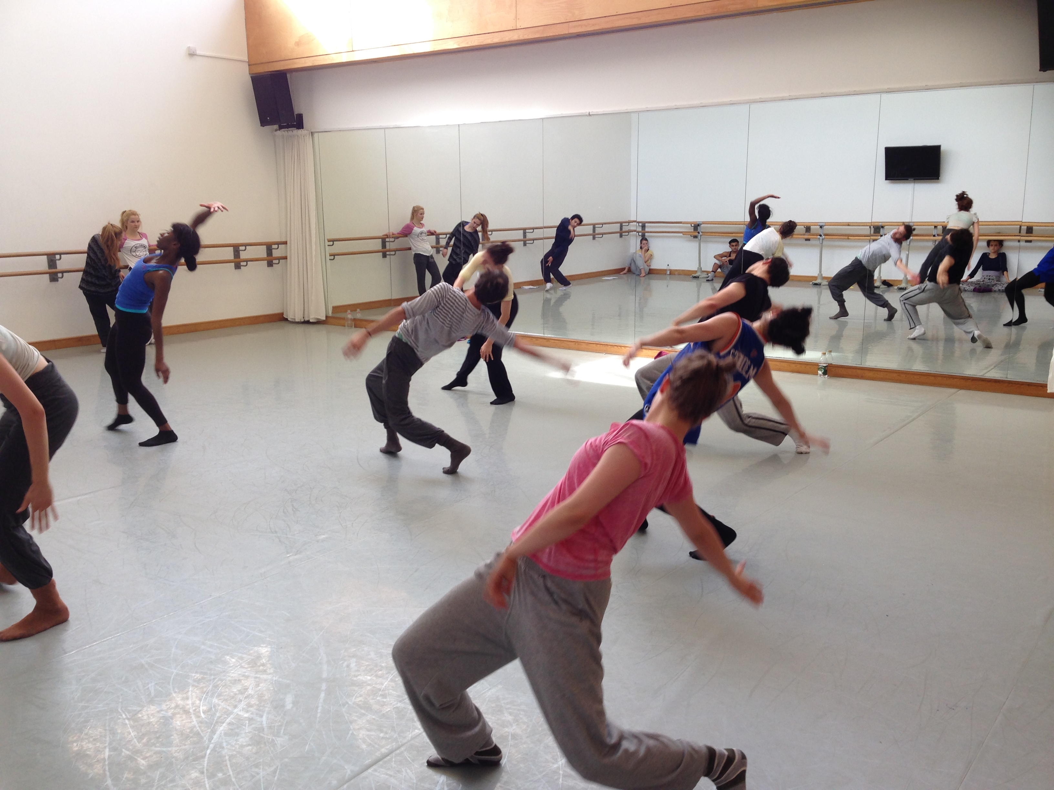
Following class, we then proceed with a short repertoire session in which the students learn short excerpts of movement from our current piece of work that's on tour. Again, age and ability are taken into consideration and all work is properly adapted to suit the level of the workshop whilst pushing the students to challenge themselves. The repertoire is then performed in small groups to prepare them for the rest of the workshop and to develop feedback and analytical skills.

The final part of the session will include creative work. We often work with the theme of what is currently on tour so that it links into the repertoire movement that was learnt, however if there is a specific focus you would like this part to take please say. We usually introduce similar methods, which are currently being used by the company to create our current touring work. Students are then able to get a feel for how devising a professional work usually begins. This includes using mind maps, discussions and improvisation to generate ideas. These ideas are then refined and the students are asked to interpret and express through movement. The creative sessions are built to improve confidence in key areas; improvisation, contact work, solo work and group created work, whilst helping to develop and improve student’s ability to create more diverse work. These short creations are then presented to their peers with feedback and the chance to work on the feedback before finishing the session off. We also offer more specialised classes, focusing on contact work, improvisation and release-based work. More details of these classes can be found in the 6th Form and
University section.

After School Dance Programme
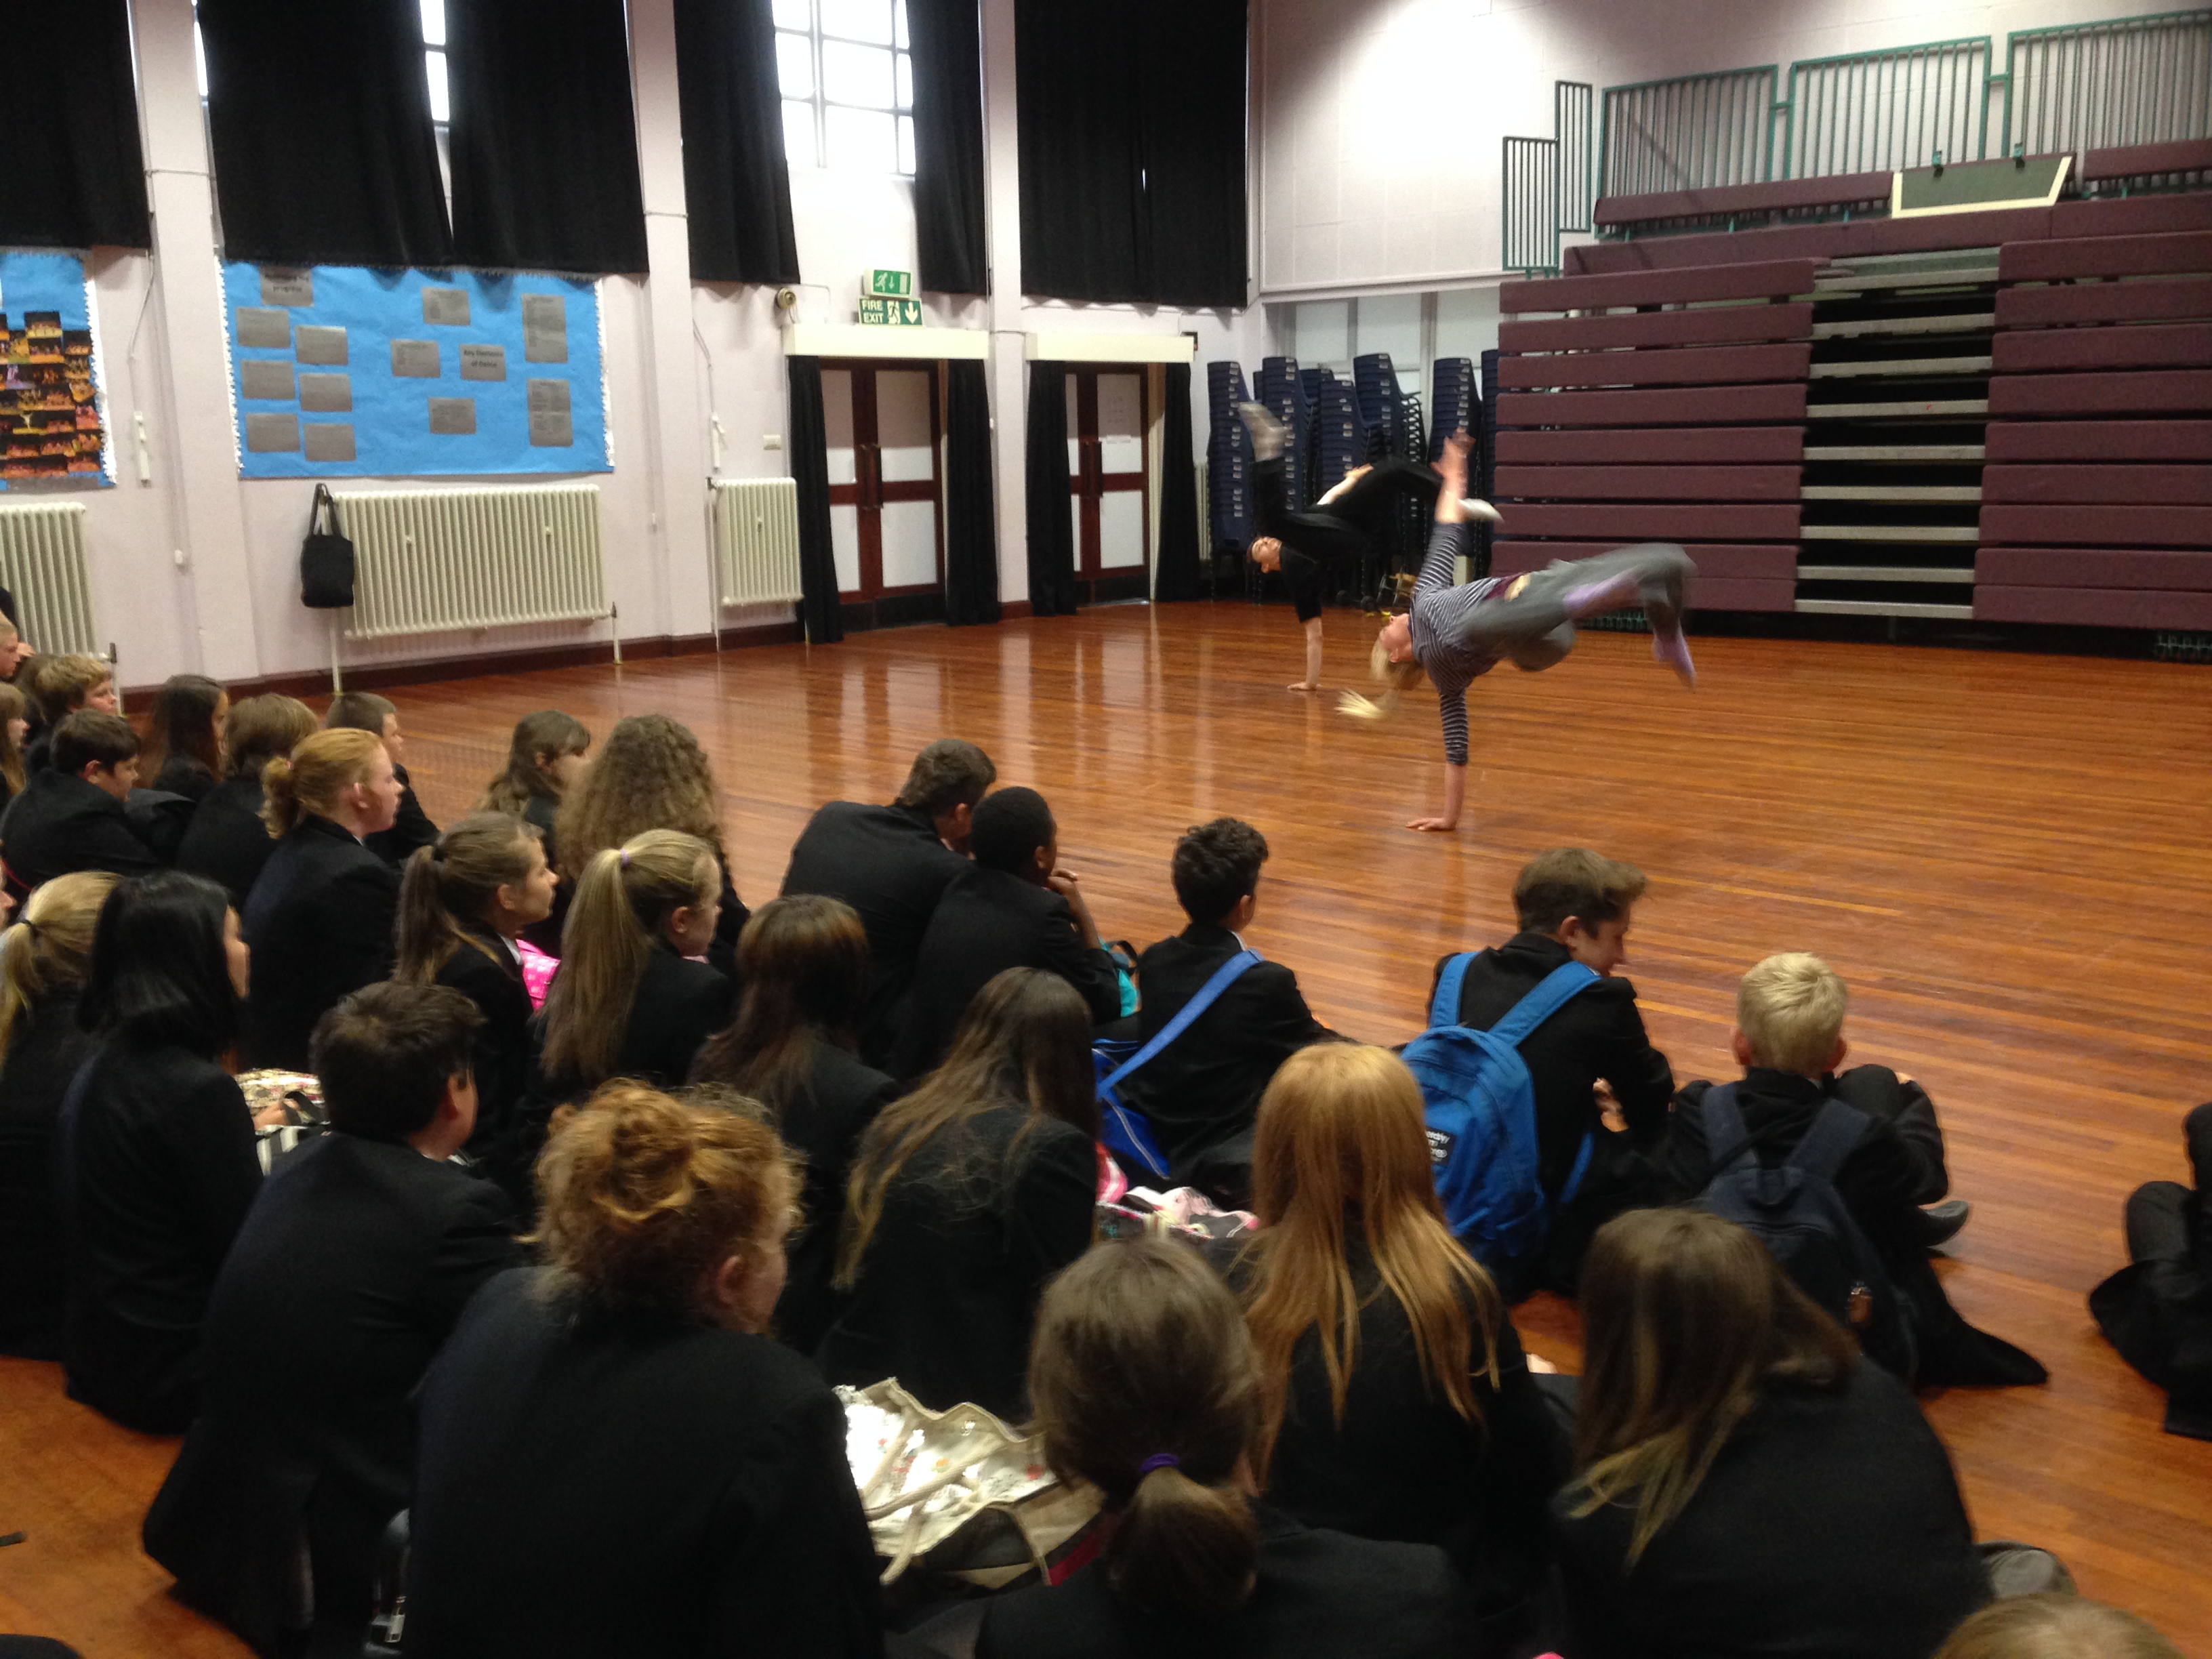
JSDC also offer regular weekly after school classes. These usually result in the preparation of a routine for performances. The classes will include a brief warm-up, technique class and repertoire session. This is often a great way for students to increase their confidence on a weekly basis, make new friends and get active. Any repertoire and student created material will be used to create performances that will have the chance to be performed at any of the annual JSDC performances that we attend or organise ourselves. The tutors JSDC provide for these classes are fully trained in the area they teach and are often current professionals in the field so are able to offer students a real insight into the current professional world. Please call or email to discuss what styles would be best brought to your school.

6th Form and University
As well as offering a similar set of classes that has been discussed in the Secondary school section, including creating pieces for AS level and A-level exams, we also offer more specialised and focused workshops in the following areas; contact work (including safe practice talks), release and improvisation. These workshops can vary in length from short 1-hour classes to full works developing a wide range of skills. Below is a brief outline of each class and what they focus on.
Contact work – Our contact workshops begin with a general overview of correct practice and health and safety. From there we begin by exploring different forms of contact improvisation based on various stimulus starting with duets. The day continues by working with new partners then exploring bigger groups.
Release – Release classes start off with a continual movement style focused mainly on floor work; it explores moving in and out of the floor. The class also focuses on exploring Alexander technique and how it can enhance movement. The class/day finishes with a personal exploration of how the early movement styles have affected the body.
Improvisation – This mixes the two previous classes, but also focuses on exploring large group improvisations, working for long periods where students move in and out of one continual improvisation with developing themes and ideas as the improvisation progresses.
Arts Award
The Arts Award is a unique qualification designed to support young people to grow as artists and arts leaders. To achieve an Arts Award, young people take on challenges in an art form, participating in arts activities, experience arts events, being inspired by artists and leading others. Arts Award’s flexible framework can be based around any arts or media activity. The award is widely recognised with a gold award carrying 35 UCAS points. JSDC currently offer the Bronze and Silver award, these are recommended for years 6-9 for Bronze and 9-11 for Silver. The award is structured around the students taking on the responsibility for completing the work with JSDC being in an advisor role, helping the students achieve the pass.
The Bronze award consists of four parts, the first is to take part in any form of arts event, the second part requires students to review an arts based event, be this a live performance or an installation; the third part is research into a artist or a craftsman that they look up too. The final part requires students to pass on their knowledge to others. While doing this, students are required to keep a portfolio of all of these events, all material collected, photos of them taking part and a journal of thoughts about what is being done. This doesn’t just have to be done by writing, video portfolios or spoken word portfolios works are accepted too. Students are encouraged to be as creative as possible. For more details on the Arts Award and the Silver award please visit www.artsaward.org.uk
Please note we strongly recommend all students have completed the Bronze award, before beginning the Silver, although it is not necessary.
JSDC deliver the Bronze award in many different ways however all require several weeks to make sure students achieve the required level of development. This can be done with group sessions to introduce the course, the aims and what will be expected of them to achieve a pass. Then follow up sessions to see how everyone is progressing with his or her portfolio, in these sessions we also discuss the important person the students researching and how they are going to do their skill share. Seeing an Arts event can be facilitated by JSDC, as we are able to provide performances in school. While Jack is working with the students they will be able to communicate with him via email to ask any questions that they will need answered before the following session.
Once all the portfolios have been completed Jack assesses them. At this point a member of staff at the Arts Award itself then moderates them. Booking in moderation can take up to 6 weeks, after that the certificates can take a further 6 weeks to be delivered. So please take this into account when booking. A break down of the finances involved can be found over the page. The fee can be split between the pupil and the school or have the student or school pay for the entire course. There are a minimum number of 20 students required to take the course, this is due to the requirements of the moderates from the Arts Award. With 20 students JSDC will provide up to 10 hours of contact time plus email support and photocopies of all guidelines to help students achieve the award. We will work with group sizes up to 25, this is to provide enough support to students at any one time. If your venue has a larger number of students we can look at splitting the groups or JSDC can get an additional advisor to support. The Arts award can be linked with any of the projects JSDC offer.

Special Commissions
JSDC also work with a number of youth groups to create specially commissioned works. Recent youth groups include Scambs, Cambridge Contemporary Dance and Caister Boys. Special Commissions work best either over a few days together or working over a few weekends to create a performance piece for a special one off youth platform or performance. JSDC are also happy with the school or groups permission to continue to apply for further festivals after the first performance. This must be discussed before the project commences.
Additional Materials
Along with all the lesson plans, technical breakdowns and music suggestions, we also offer a range of posters to help assist and develop the student’s knowledge of dance terms. These poster cover a wide range of technical terms, uses of space and use of dynamics. Below are a couple of examples of what the pack contains. The pack contains 20 pages that can either be sent to you via email (all documents are in a word format) or can be delivered to you while JSDC are working in your school.
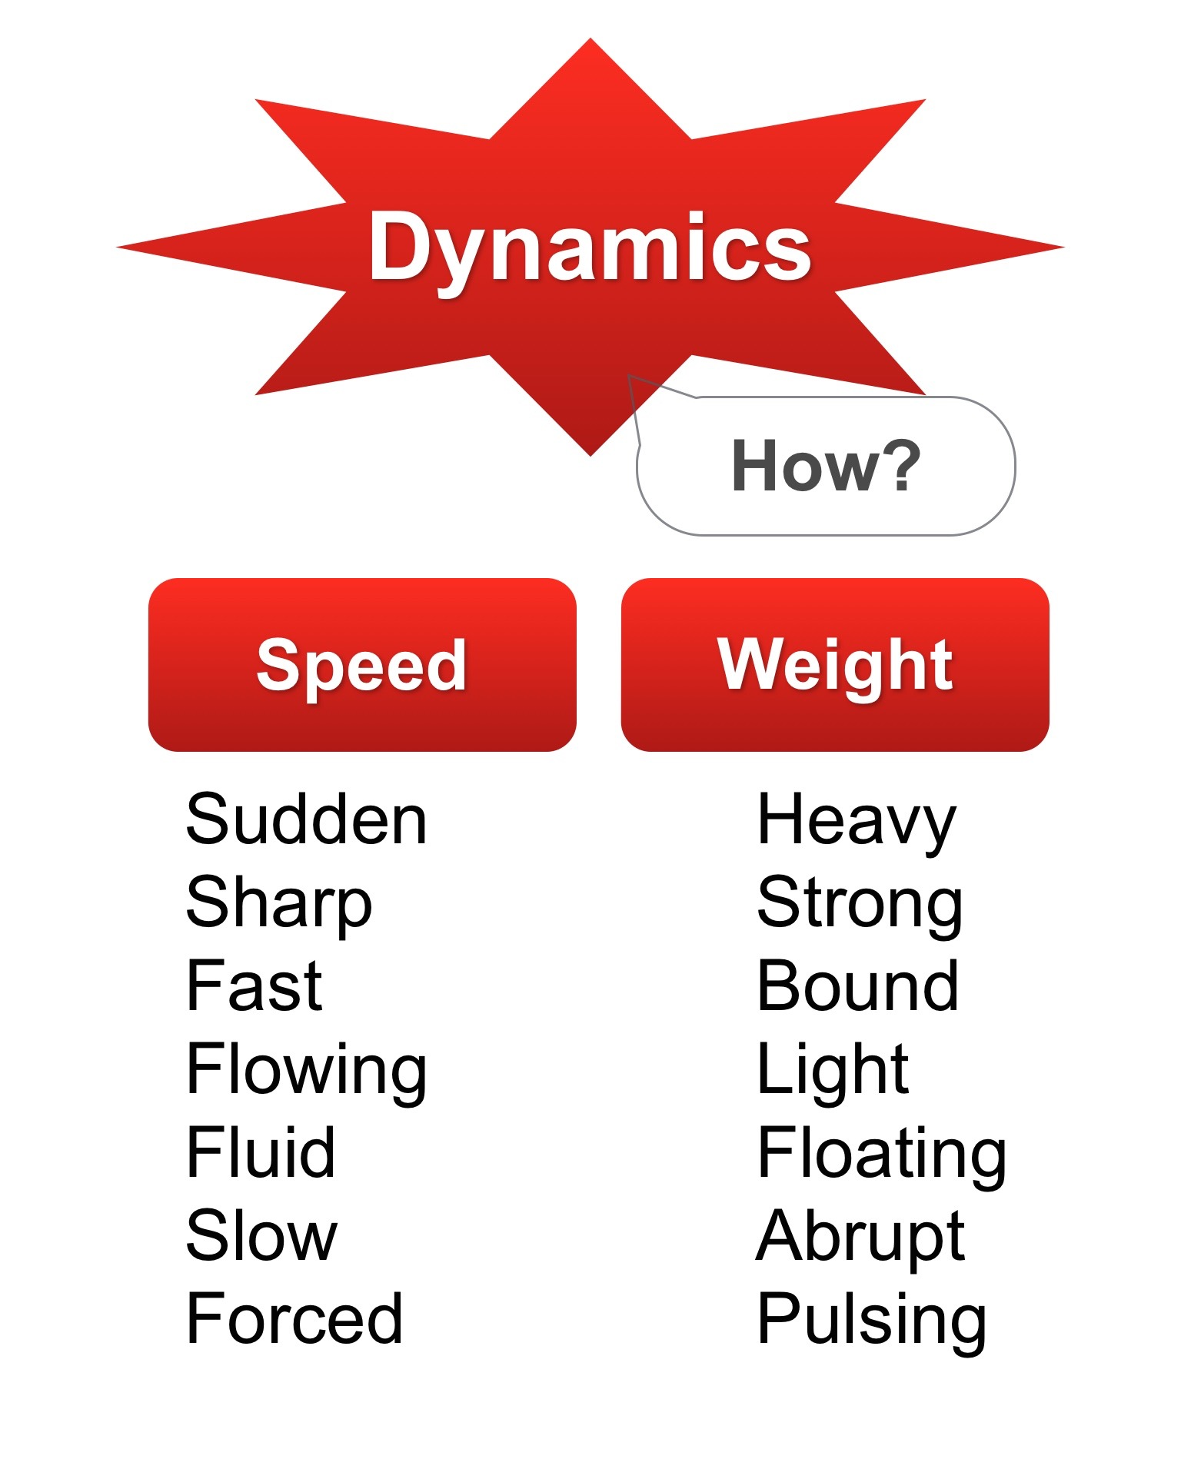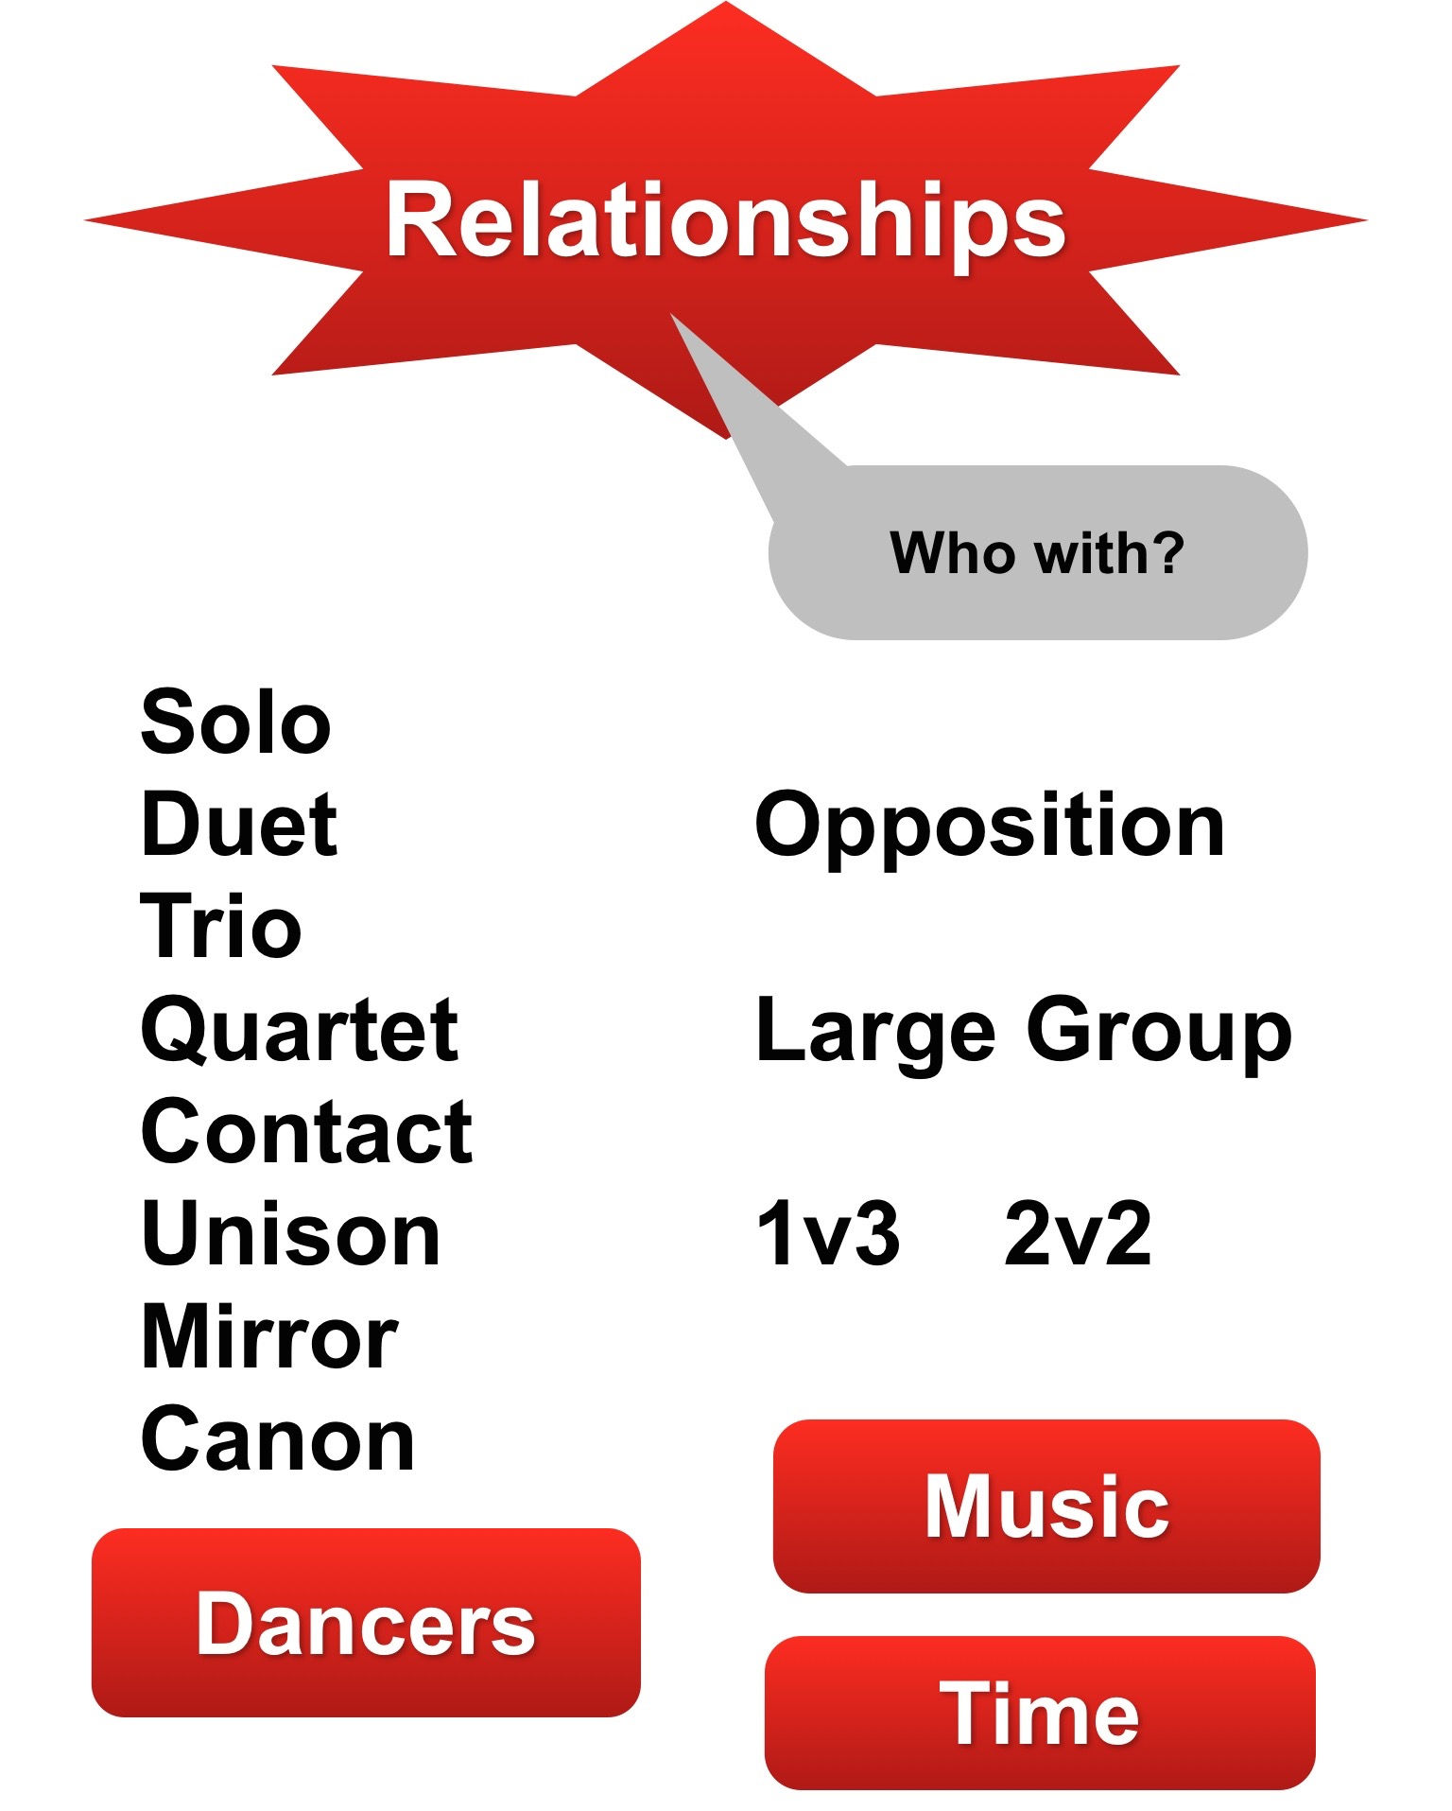
We also have all our lesson plans available for purchase; these lesson packs are usually 6 weeks long. We also have courses that vary in length. We have a range or topics covered and a wide range of ages as well. For more information on what topics we have covered please get in touch.

Financial Details
Below is a general overview of the pricing structure for all of the outlined workshops within this package. For a more detailed breakdown of our costs please contact
jack@jackstintondancecompany.com

All Day Workshop £175 – Single member of staff
£250 – Full company workshop*

Single PE/Dance £30 per session**
Class (GCSE & BTEC)

After School Classes £30 per session or JSDC hirer a
school hall/studio and
students pay a small cost
per class

Arts Award £30 per student. Minimum of 20 students.
£4 Arts award log & guidance booklet****

Additional Material £20 per poster pack***
£30 per lesson pack
£40 Both Packs

*Only available when the company is touring
**Discounts on half term bookings and longer
***Unlimited use within your school setting
****Not required to complete the award

About the Company

Jack Stinton – Artistic Director

Jack started dancing at secondary school when he was 14, where he was introduced to contemporary dance. He took part in a week’s residency with Kenneth Tharp (Chief Executive of the Place). From this workshop Jack was introduced to his long time teachers April Martin and Diccon Hogger. Jack worked with many local choreographers during this first part of his training included Lorena Randi, Amy Holly and Maria Blundell. Jack was offered a place at the Northern School of Contemporary Dance in 2008 on the Foundation Course then in 2009 their Degree Course.

During his time at Northern Jack worked with a number of current professionals working in the field including Lloyd Newson, Matthew Bourne and Hofesh Shechter. Gaining his BPA (Hons) Degree in the summer of 2012 with a major in Choreography. In his final year he formed Jack Stinton Dance Company. The company’s first public performance was at Energise 2012.

Since then the company has gone from strength to strength from performing at Edinburgh Fringe Festival to a headlining slot at Resolution! 15. The company has 4 works that are continually on tour or in the studio being worked on. Our newest performance project is set to begin work in the autumn of 2015. Our education program has also grown rapidly, now with over 25 weekly classes teaching primary ballet to contemporary at universities to teaching over 60s street dance. The education style is fun but designed to push and challenge all our pupils to find new moves a new level of fitness or a deeper understanding of dance.

All the programs we offer help to achieve this.

Many thanks for taking the time to read through our current pack. We hope this has provided an insight into the work of Jack Stinton Dance Company and what we can provide for your setting. If something isn’t listed that you would like to discuss with JSDC please do get in touch and we will do our best to accommodate your needs.

If you would like to book any of the packages mentioned, or have any queries please do not hesitate to contact Jack at
jack@jackstintondancecompany.com

